|  |  |  |
| --- | --- | --- |
| **QR Payments System** | | |
|  | | |
|  | | |
|  | | |
|  | | |
|  | | |
|  | | |
| **A DESIGN PROJECT REPORT SUBMITTED**  **IN PARTIAL FULFILLMENT FOR THE AWARD OF THE DEGREE OF**  **BACHELOR OF TECHNOLOGY IN**  **COMPUTER SCIENCE ENGINEERING**  **and**  **INFORMATION TECHNOLOGY** | | |
|  | | |
| **Submitted by** | | |
|  | | |
|  | | |
| **K. Ananya** |  | **20071A05E5** |
| **K. Tejaswini** |  | **20071A1225** |
| **M. Harikesh** |  | **20071A6629** |
| **N. Parthav** |  | **20071A6637** |
| **S. Sana Siddiqa** |  | **20071A6650** |
|  |  |
|  | | |
|  | | |
|  | | |
|  | | |
| **VALLURUPALLI NAGESWARA RAO VIGNANA JYOTHI**  **INSTITUTE OF ENGINEERING AND TECHNOLOGY** | | |
| An Autonomous, ISO 9001:2015 & QS I-Gauge Diamond Rated Institute, Accredited by NAAC with ‘A++’ Grade  NBA Accreditation for B.Tech. CE,EEE,ME,ECE,CSE,EIE,IT,AME, M.Tech. STRE, PE, AMS, SWE Programmes  Approved by AICTE, New Delhi, Affiliated to JNTUH, NIRF (2022) 113 Rank in Engineering Category  College with Potential for Excellence by UGC,JNTUH-Recognized Research Centres:CE,EEE,ME,ECE,CSE Vignana Jyothi Nagar, Pragathi Nagar, Nizampet (S.O.), Hyderabad – 500 090, TS, India.  Telephone No: 040-2304 2758/59/60, Fax: 040-23042761  E-mail: [postbox@vnrvjiet.ac.in](mailto:postbox@vnrvjiet.ac.in), Website: [www.vnrvjiet.ac.in](http://www.vnrvjiet.ac.in) | | |
|  | | |
| **2022-2023** | | |

|  |  |  |
| --- | --- | --- |
| **VALLURUPALLI NAGESWARA RAO VIGNANA JYOTHI**  **INSTITUTE OF ENGINEERING AND TECHNOLOGY**  **CENTRE FOR PRESENCING AND DESIGN THINKING** | | |
| An Autonomous, ISO 9001:2015 & QS I-Gauge Diamond Rated Institute, Accredited by NAAC with ‘A++’ Grade  NBA Accreditation for B.Tech. CE,EEE,ME,ECE,CSE,EIE,IT,AME, M.Tech. STRE, PE, AMS, SWE Programmes  Approved by AICTE, New Delhi, Affiliated to JNTUH, NIRF (2022) 113 Rank in Engineering Category  College with Potential for Excellence by UGC,JNTUH-Recognized Research Centres:CE,EEE,ME,ECE,CSE Vignana Jyothi Nagar, Pragathi Nagar, Nizampet (S.O.), Hyderabad – 500 090, TS, India.  Telephone No: 040-2304 2758/59/60, Fax: 040-23042761  E-mail: [postbox@vnrvjiet.ac.in](mailto:postbox@vnrvjiet.ac.in), Website: [www.vnrvjiet.ac.in](http://www.vnrvjiet.ac.in) | | |
|  | | |
|  | | |
|  | | |
|  | | |
|  | | |
|  | | |
| **CERTIFICATE** | | |
|  | | |
| This is to certify that the project titled **QR Payments System** is being submitted, by **K. Ananya (20071A05E5, CSE)**, **K. Tejaswini (20071A1225, IT)**, **M. Harikesh (20071A6629, CSE-AIML)**, **N. Parthav (20071A6637, CSE-AIML) and S. Sana Siddiqa(20071A6650, CSE-AIML)** in partial fulfilment of the requirement for the award of degree of **Bachelor of Technology** to the Centre for Presencing and Design Thinking at **Vallurupalli Nageswara Rao** **Vignana Jyothi Institute of Engineering and Technology** is a record of *bonafide* work carried out by them under our pedagogy. The results embodied in this Project have not been submitted to any other University or Institute for the award of any degree. | | |
|  |  | **Project Mentor**  **Name & Designation:**  **J. Sravanthi - Assistant Professor** |
|  |  | **Dept.: Information Technology** |
|  |  | **VNRVJIET** |
|  |  | **Hyderabad** |
|  | | |
| **Internal Examiners External Examiners** | | |

**ABSTRACT**

In an initiation to establish digitalized India, one of the vastly used inventions came into being which is the online payment system referred to as Unified Payments Interface (UPI) which created cashless digitalized transactions. Payments through UPI are done using the internet, and one often fails to make payments due to improper internet connectivity at the places they wish to pay. It could be even more useful if these payment systems work without internet connectivity i.e., the development of an offline payment system. The QR Payments system can be considered as a mini offline payment system that is developed to digitalize the transactions made in the canteen of VNR VJIET which works without internet connectivity. Students often face the problem of improper internet connectivity in the college because of which they fail to make their UPI payments to the canteen, the QR Payments system resolves this problem as it helps the students by not asking for any internet connectivity to make a payment. Payments are done just by scanning a generated QR code which operates the database that contains the details of the user, stalls, food items, and prices. Students are required to deposit money with the college management, and the payments made by the students will be appended to the respective databases designed for college management, student, and food stalls.

**LITERATURE SURVEY**

Offline digital payments are cashless payments that occur without Wi-Fi, mobile data, or hot spots. In India, the Reserve Bank recently released a framework to make these payments possible. Offline digital payment provides a seamless experience to the end users and reduces failures due to connectivity issues.

### How to use them?

The user would initiate a transaction via a prepaid card, e-wallet, or mobile wallet and then verify themselves using a password or PIN. If they are close enough to the payment receiver, a transaction will be made.

One example of this is through devices like smartphones, which have the technology for near-field communication (NFC). It allows for data exchange when devices are within close enough range, and the NFC technology is turned on.

Another way offline cashless payments can be made is through the asynchronous route. A transaction would be initiated, and when an internet or mobile connection resumes, the payment would be processed.

**Example: ALIPAY**

The barcode/QR Code payment is an offline instant payment solution offered by Alipay for the in-store checkout. This payment solution enables merchants to collect money by scanning the barcode/QR code that is shown on a customer’s Alipay wallet app. The barcode/QR code payment solution is also known as "merchant-scan solution", which is contrary to another kind of offline solution "customer-scan solution" where customers scan the QR code presented by the merchant. One great advantage of using the barcode/QR code payment is that it does NOT require the Alipay Wallet App to have an internet connection.

The barcode/QR code essentially identifies the owner of Alipay Wallet, with which Alipay knows which customer's account is to be charged for the payment. In addition, the code is auto-refreshed every minute in the Alipay Wallet App without requiring the internet connection.

**TABLE OF CONTENTS**

|  |  |  |
| --- | --- | --- |
| **Details of Contents** | | **Page no.** |
|  | | |
| **Abstract** | | **iii** |
| **Literature Survey** | | **iv** |
| **Table of Contents** | | **v** |
| **List of Figures** | | **vi** |
|  | |  |
|  | | |
| **Chapter 1: Introduction to Problem** | | **1** |
| **1.1 Objective** | | **1** |
| **1.2 Outline** | | **1** |
| **1.3 Motivation** | | **1** |
| **1.4 Scope of the Project** | | **1** |
| **Chapter 2: Discover and Define** | | **2** |
| **2.1 Empathy Interview**  **2.2 Persona** | | **2**  **6** |
| **2.3 User Needs** | | **6** |
| **Chapter 3: Customer service experience** | | **7** |
| **3.1 Service experience cycle** | | **7** |
| **3.2 Pain point address** | | **7** |
| **Chapter 4: Ideation** | | **9** |
| **4.1 Ideation Tools** | | **9** |
| **4.2 Outcome of Ideation Phase** | | **9** |
| **Chapter 5:** | | **10** |
| **5.1 Prototype model** | | **10** |
| **5.2 Evaluation of prototype Based on Desirability, Feasibility & Viability** | | **25** |
| **5.3 Design for environment** | | **25** |
| **Chapter 6: Conclusions and Future Scope** | | **26** |
| **6.1 Conclusions** | | **26** |
| **6.2 Future Scope** | | **26** |
| **References** | **27** | |
| **Appendix A: User Surveys** | | **28** |
| **A.1 Questionnaire for Users** | | **28** |
| **A.2 Text Transcripts of User Responses** | | **28** |

|  |  |
| --- | --- |
|  |  |
|  | |
|  |  |
|  |  |
|  |  |
|  |  |
|  |  |
|  |  |
|  |  |

**LIST OF FIGURES**

|  |  |
| --- | --- |
| **Figure 2.1.a: Survey**  **Figure 2.1.b: Survey**  **Figure 2.1.c: Survey**  **Figure 2.1.d: Survey**  **Figure 2.1.e: Survey**  **Figure 2.1.f: Survey**  **Figure 2.1.g: Survey**  **Figure 5.1:        Home Page**  **Figure 5.2:        Login Page**  **Figure 5.3:        Stalls Page**  **Figure 5.4:        Orders Page**  **Figure 5.5:        Enter Pin Page**  **Figure 5.6:        Render QR Code**  **Figure 5.7:        QR Scanner**  **Figure 5.8:        Scanning QR for first time**  **Figure 5.9:        Scanning QR for second time**  **Figure A.2.a:    Survey** | **2**  **3**  **3**  **4**  **4**  **5**  **5**  **6**  **7**  **8**  **9**  **10**  **11**  **12**  **13**  **14**  **28** |
| **Figure A.2.b:    Survey** | **29** |
| **Figure A.2.c:    Survey**  **Figure A.2.d:    Survey**  **Figure A.2.e:    Survey** | **29**  **30**  **30** |

# CHAPTER 1

# INTRODUCTION

## 1.1 Objective

Today, we all are well familiar with the iconic black and white square design of a QR code. The increased penetration of smartphones and access to high-speed internet has led to the massive adoption of the QR codes. That’s the reason why we see it almost everywhere whether it’s for shopping, movies, ads, etc. But if there is a lack of a high-speed network, then doing any of the work is not possible. The objective of this project is to develop a QR payment system that will work even when the user is offline.

## 1.2 Outline

This project “QR Payments System” is made with the motive of enabling users to make digital payments when they are offline. This project is restricted to the premises of our college canteen area. We were motivated to solve this problem when we faced the problem of making our UPI payments while ordering food in the college canteen. Due to lack of proper internet services, making a UPI payment is very hard. The survival of this project is with few assumptions like: the college maintains a student account where the user deposits his pocket money, the food stall owners were provided with internet connectivity (Wi-Fi) by the college, student has an all-time updated QR Generation app on his device to make payments successful. This project has two distinct products and their implementation. The first product is a QR Generator used by students. The second product is a QR Scanner used by food sellers.

## 1.3 Motivation

It is observed that due to lack of internet connectivity at our college canteen it is not possible to make UPI payments easily. Sometimes, after placing the order we can't make the payment which puts us in an awkward situation. These situations motivated us to build a QR Payments System which allows users to make digital payments even when you are offline.

## 1.4 Scope for the Work

With the UPI we got used to digital payments. So, it lets us take it a step forward and try to enable users to make digital payments even when they are offline. It would be helpful in the situation where there is a lack of internet connectivity and network signals. It will also reduce the amount of paper generated QR codes simplify the process by cutting short everything into one simple scan.

# CHAPTER 2

# DISCOVER AND DEFINE

## 2.1 Empathy Interview

A survey has been conducted which includes everyone who orders food near the college canteen counter and are facing issues with proper internet connectivity.

## 2.1.1 Questionnaire

1. Have you ever faced difficulty in internet connectivity at college canteen?
2. Have you ever been in a situation where you have ordered your food and are unable to make a UPI payment due to lack of internet access?
3. If we provide you a service that enables you to make digital payments when you are offline. Do you think it's useful? (Services are restricted to college)
4. It's good to carry money rather than having such a service.
5. Do you think this application can make your process of placing an order easy?
6. What features would you be expecting from this application?
7. User Persona (you can share any of your experience if you have ever came across a situation as described above)

**2.1.2 Answers**

Out of the total students surveyed 93.5% of people faced difficulty with internet connectivity.

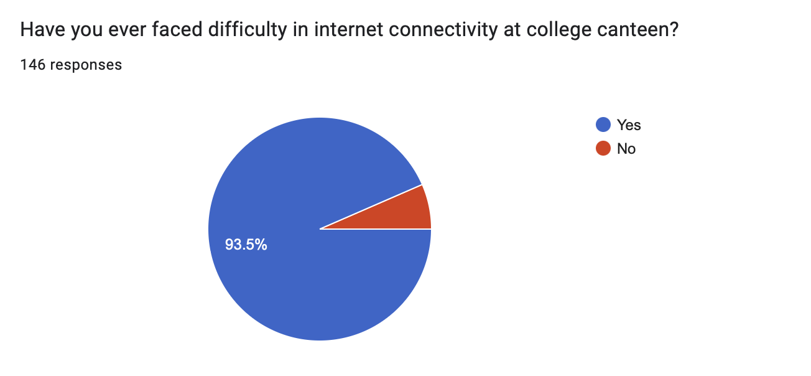

**Fig-2.1.a Survey**

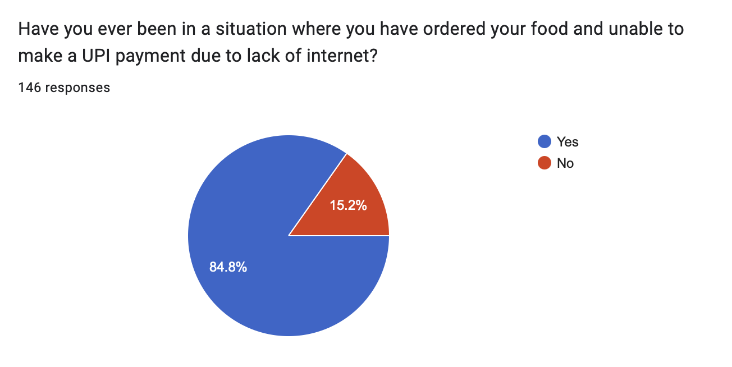

**Fig-2.1.b Survey**

Out of 146 students 84.8% were unable to make successful UPI payments due to lack of internet.

They faced an awkward situation of being unable to pay after ordering the food.

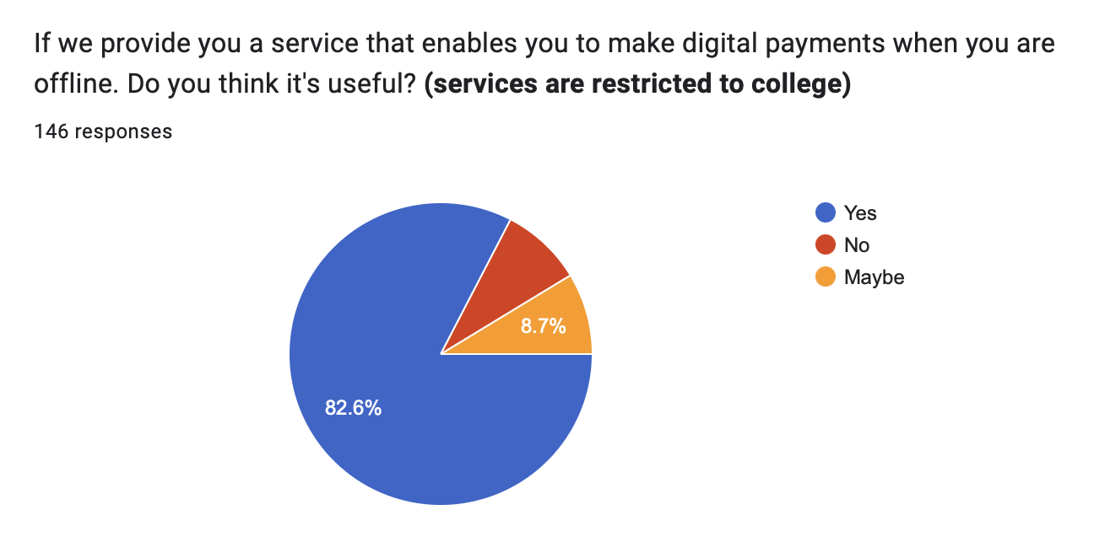

**Fig-2.1.c Survey**

Out of 146 students 82.6% felt that a platform for making offline digital payments would be helpful.

While 8.7% answered it as it depends on the service provided.

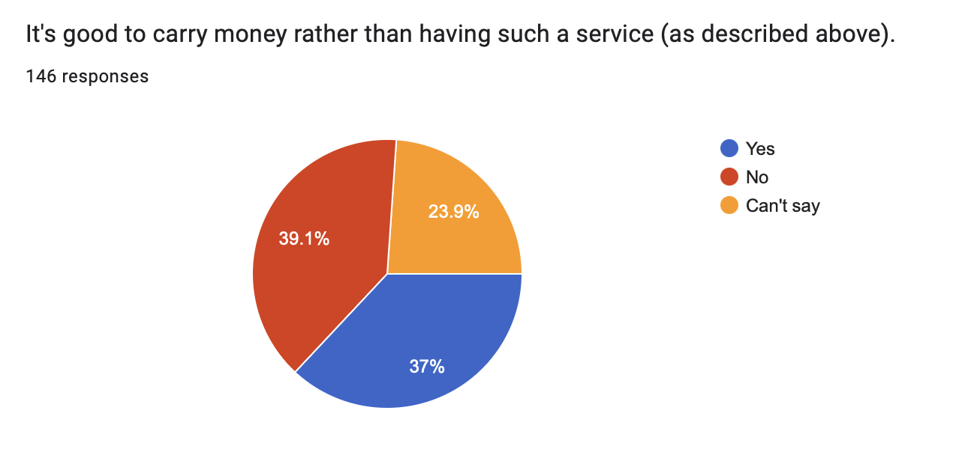

**Fig-2.1.d Survey**

Out of 146 responses 39.1% felt that it is good to have such a platform.

While 37% said it's good to carry money to avoid any such issues with food ordering.

23.9% felt that it depends on the solution provided.

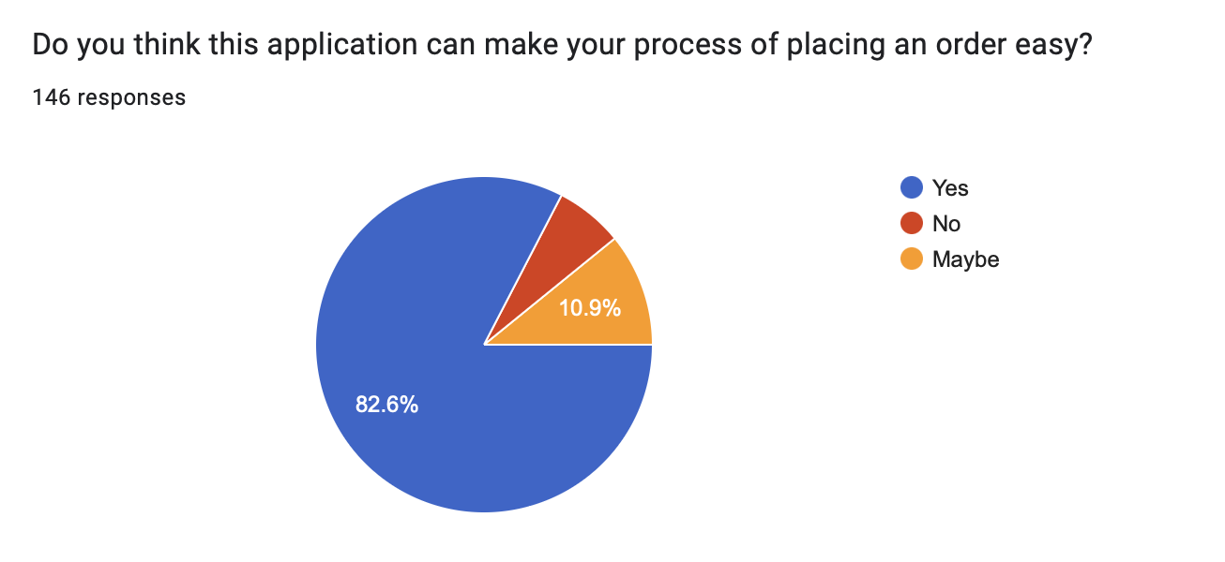

**Fig-2.1.e Survey**

82.6% of people felt this sort of application will be helpful in making their process of ordering food easy.

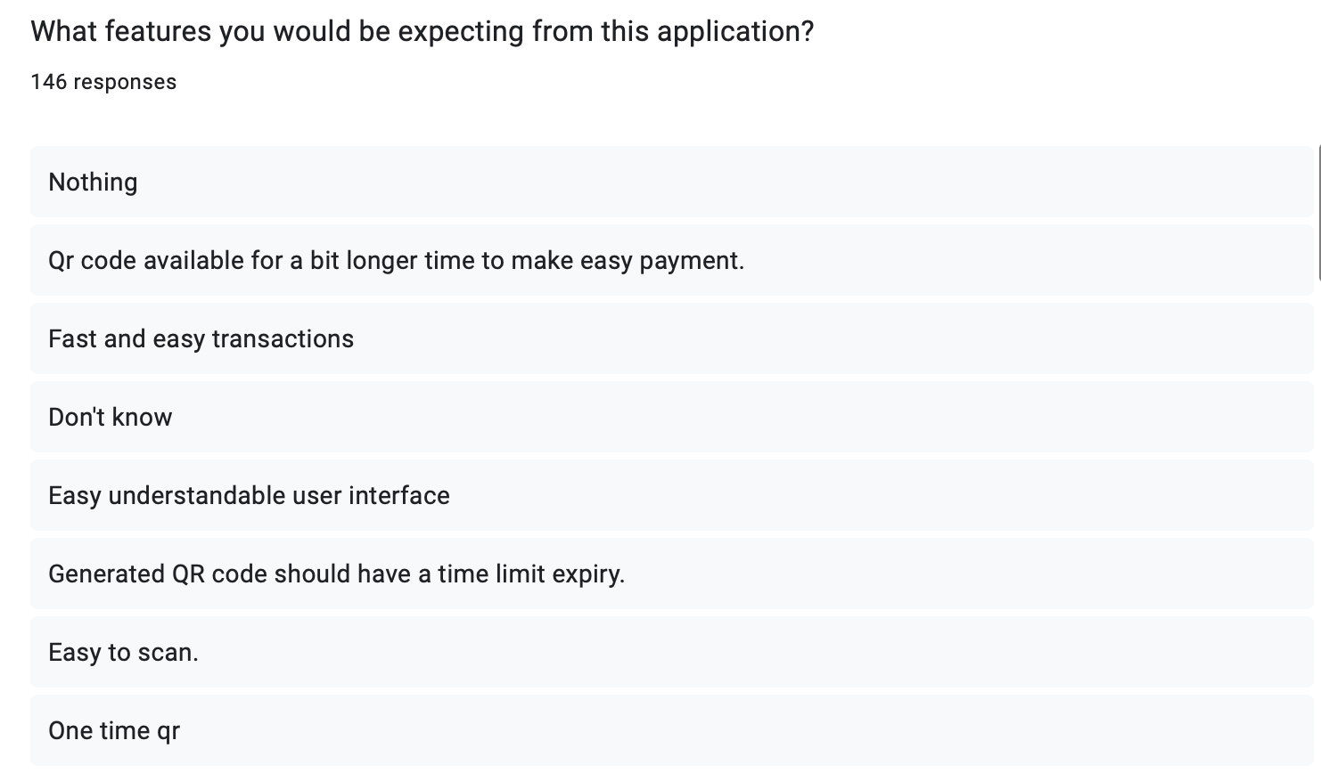

**Fig-2.1.f Survey**

Various users shared their expectations or needs through this section.

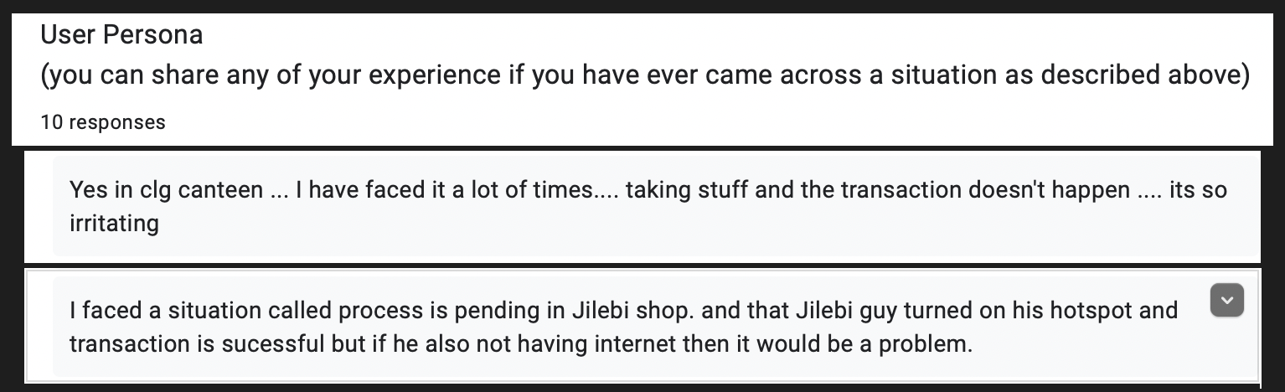

**Fig-2.1.g Survey**

This section is used for collecting the user persona. Through this section users shared their experience regarding the payment failure while food ordering.

**2.2 Persona**

* **Students**

All those students who ever faced any trouble in making a payment may find this solution helpful. Students who faced an awkward situation of ordering food and unable to pay through UPI can relate themselves to this problem.

* **Vendors**

It becomes easy for the vendors to handle transactions and keep note of the order history. This platform helps in fast completion of transactions.

**2.3 User Needs**

**2.3.1 Primary needs**

* Make digital payments while offline.
* Secure and fast transactions through QR Code.
* Interactive User Interface of application.

**2.3.2 Secondary needs**

* Password and Pin encryption.
* Ability to download generated QR Code.

**2.3.3 Latent needs**

* Generated QR should work for 5mins.
* QR can be used only once.

# CHAPTER 3

# CUSTOMER SERVICE EXPERIENCE

## 3.1 Service Experience Cycle

### 3.1.1 Task Flow

Task flow represents the steps we followed to create the prototype.

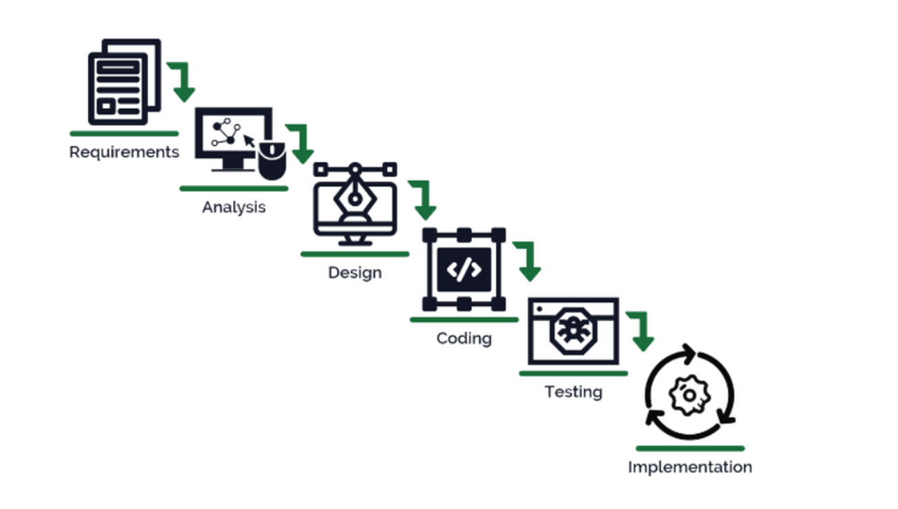

## 3.1.2 Focus Areas

## Our prime focus here is on the students who pay for the food they buy in the canteen using the UPI.

## 3.2 User Pain Points

**1. Students:**

•Students face some problems during the payments for their food orders.

•This application tries to solve these problems by allowing the students to make offline payments.

**2.** **Vendors:**

•This helps in easy analysis of their order history and transactions.

•Vendors can’t have the list of the items ordered by the students for the amount they received through the UPI.

•This application can be an answer to such problems as we will have the order history for each transaction.

## 3.2.1 Gains Expected

• Students can easily perform digital payments while offline.

• Environment friendly as paper is not being wasted for generating bills.

• Vendors will be benefited due to these fast and easy transactions.

# CHAPTER 4

# IDEATION

## 4.1 Ideation Tool Used - Brainstorming

* The initial ideation of the solution was to build an application at the vendor side to take the orders.
* It has a high implementation cost and requires a large amount of resources.
* During brainstorming, we got the idea of using QR codes to accept orders.
* All we need is a medium that carries our information to the machine.
* Using a QR Code meets this requirement.

## 4.2 Ideation Outcome

The solution is devised through mind mapping and brainstorming with consideration for all stakeholders in order to be feasible and user-friendly for everyone.

### 4.2.1 Student perspective

Students use the QR Generator app ( as of now is a hosted web application ) to generate QR codes. These QR codes reflect the user-placed food orders. In this application, the user logs in while connected to the internet. The user can still create QR codes when offline.

It contains information about food vendors, goods, and prices.

The user can choose how much food to order and input a pin when creating the QR code. Before being included in the QR code, the pin will be encrypted. Thus, a user can order food using a QR code. Since he has logged into the app, the QR code includes his username (roll number). This equipment has been designed to replace any order-taking touch panels in order to reduce costs.

### 4.2.2 Seller perspective

QR scanners will be placed at the desks of the food vendors.

This makes taking food orders from students easier. This QR scanner will read the QR code, comprehend the user's meal order, pull the user's login information, and validate the user. Once the user has been confirmed, the system checks the QR code based on the date it was generated and whether it has been attempted to be used before. After the QR code has been successfully validated and the user account has been shown to have enough funds, the transaction will be complete.

# CHAPTER 5

# PROTOTYPE MODEL

## 5.1 Solution Prototype

The proposed solution has been developed as two different applications. They are:

1. QR Generator (Web-Application)
2. QR Scanner

### 5.1.1 QR Generator (Web-Application)

This web application has been built using HTML5, CSS3 and Flask. This application has been hosted using python anywhere platform.

**QR Generator UI**

**STEP-1: Home Page**

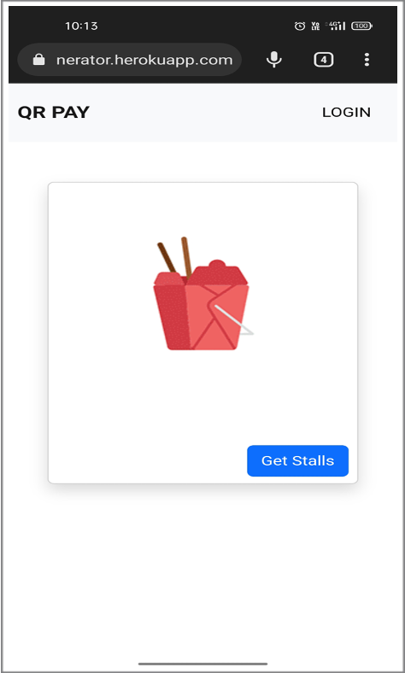

**Fig-5.1 Home Page**

#### STEP-2: Login Page

Get redirected to the login page on clicking the Login button or Get Stalls button (before login). The login credentials were given to login to the application.

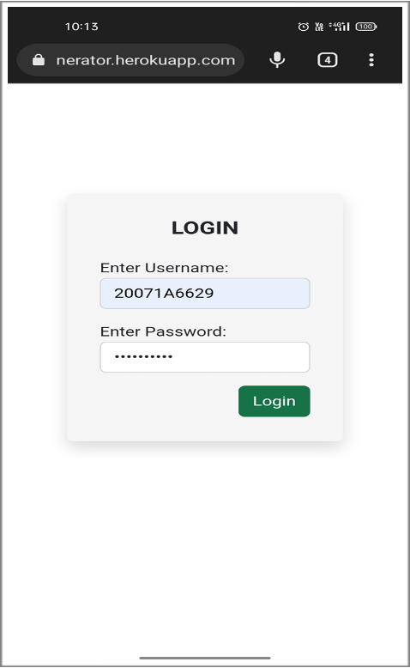

**Fig-5.2 Login Page**

**STEP-3: Stalls Page**

We can view all the available stalls by clicking on the Get Stalls page. This page shows various stalls available to place orders.

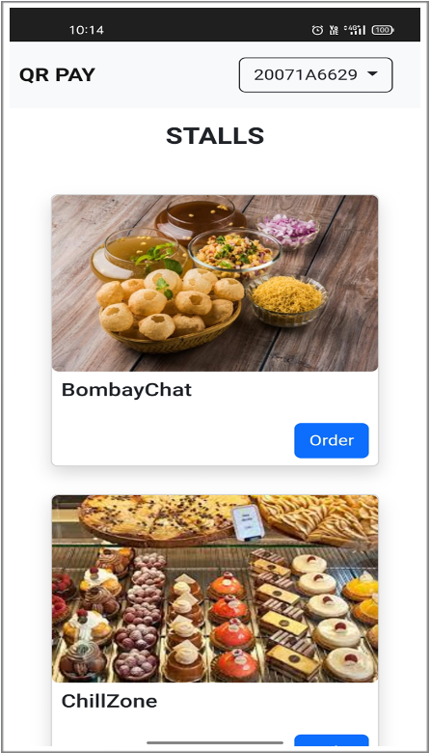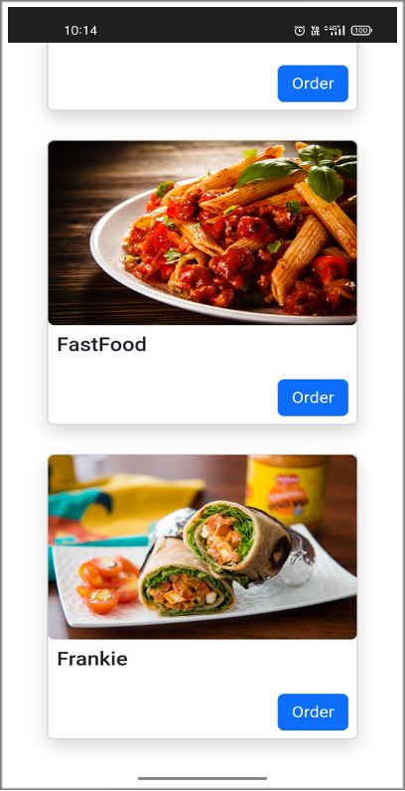

**Fig-5.3 Stalls Page**

**STEP-4: Place Order / Choose Items**

By clicking on order we get redirected to the Order Food Page. Here, we can see all the available food items. On clicking add the quantity will be incremented. On clicking remove the quantity will be decremented. The subtotal and grand total amount will be generated based on the quantity selected.

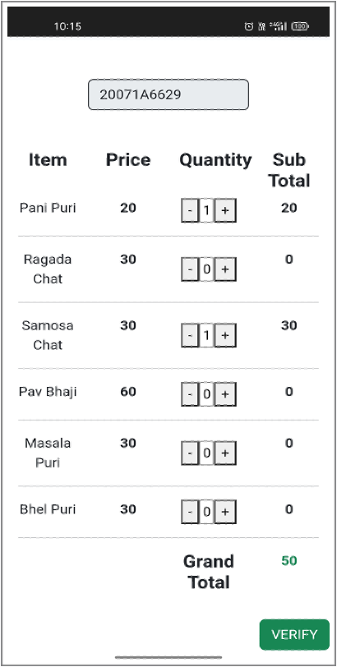

**Fig-5.4 Orders Page**

**STEP-5: Verify Pin**

On clicking the verify button we get redirected to the verify pin page. Here, we enter our pin (similar to UPI pin i.e., independent of payments platform) to verify us. After successful verification of the pin the data will be encoded and a QR Code will be generated.

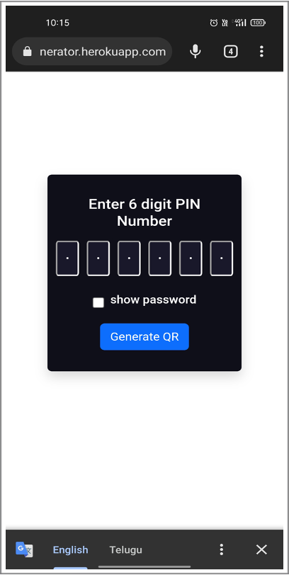

**Fig-5.5 Enter Pin Page**

**STEP-6: Render QR Page**

This page will be used to render the generated QR Code. We have two options called clear session and download QR. The clear session will be used to clear the cache of the session and redirect to the Home Page. The download QR is used to download the generated QR as an image.

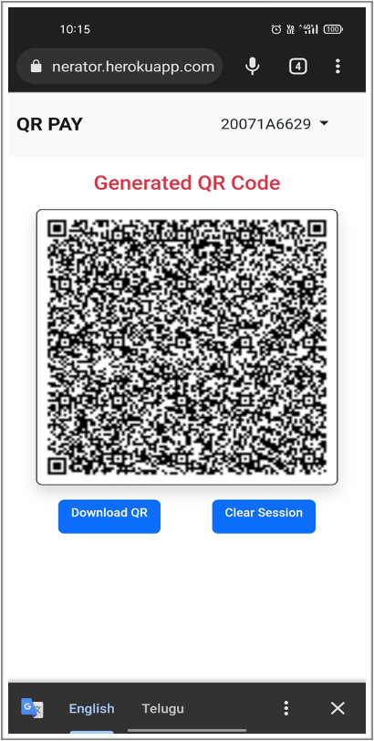

**Fig-5.6 Render QR Code**

#### 5.1.2 QR Scanner

The QR Scanner is used at the vendor side. It is built using opencv and pyzbar. It is used to scan the generated QR Code and extract the encoded information. This extracted information is used in different processes like:

1. Verify User
2. Validate QR Code
   1. Validation based on generation time (QR is valid for 5 mins).
   2. Validation based on unused QR.
3. Verify order items prices
4. Compute bill
5. Verify sufficient funds in user account
6. Complete transaction

## STEP-1: Scan QR Code

The vendor side application is used to run the scanner part. This opens the machine camera using opencv and continues to take each frame until a valid data is extracted from encoded QR Code.

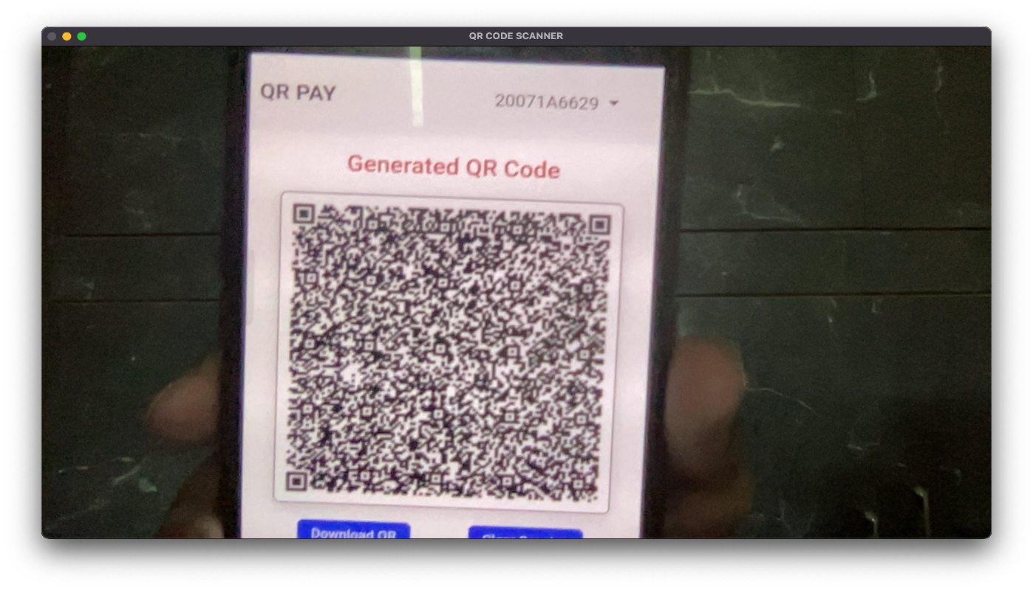

**Fig-5.7 QR Scanner**

## STEP-2: Scanning QR for first time

This QR is scanned for the first time and used within 5 mins from the time of generation. This has to complete the transaction successfully if there are sufficient funds.

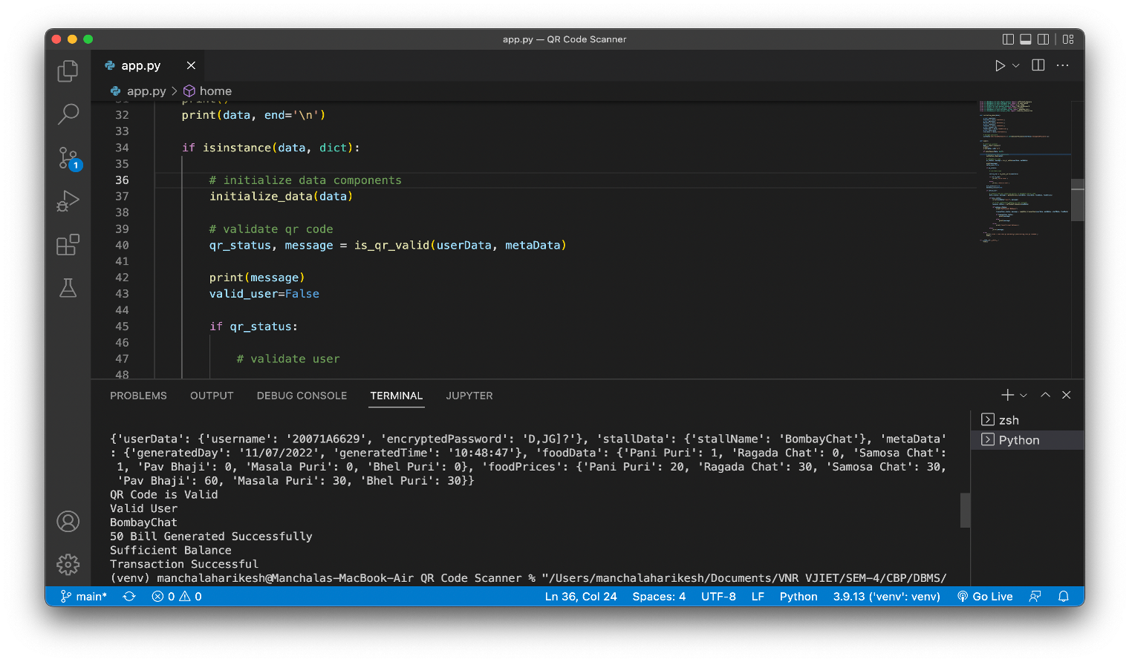

**Fig-5.8 Scanning QR for first time**

**STEP-3: Scanning QR for second time**

This QR is scanned for the second time and the scanner has to raise an error without completing the transaction.

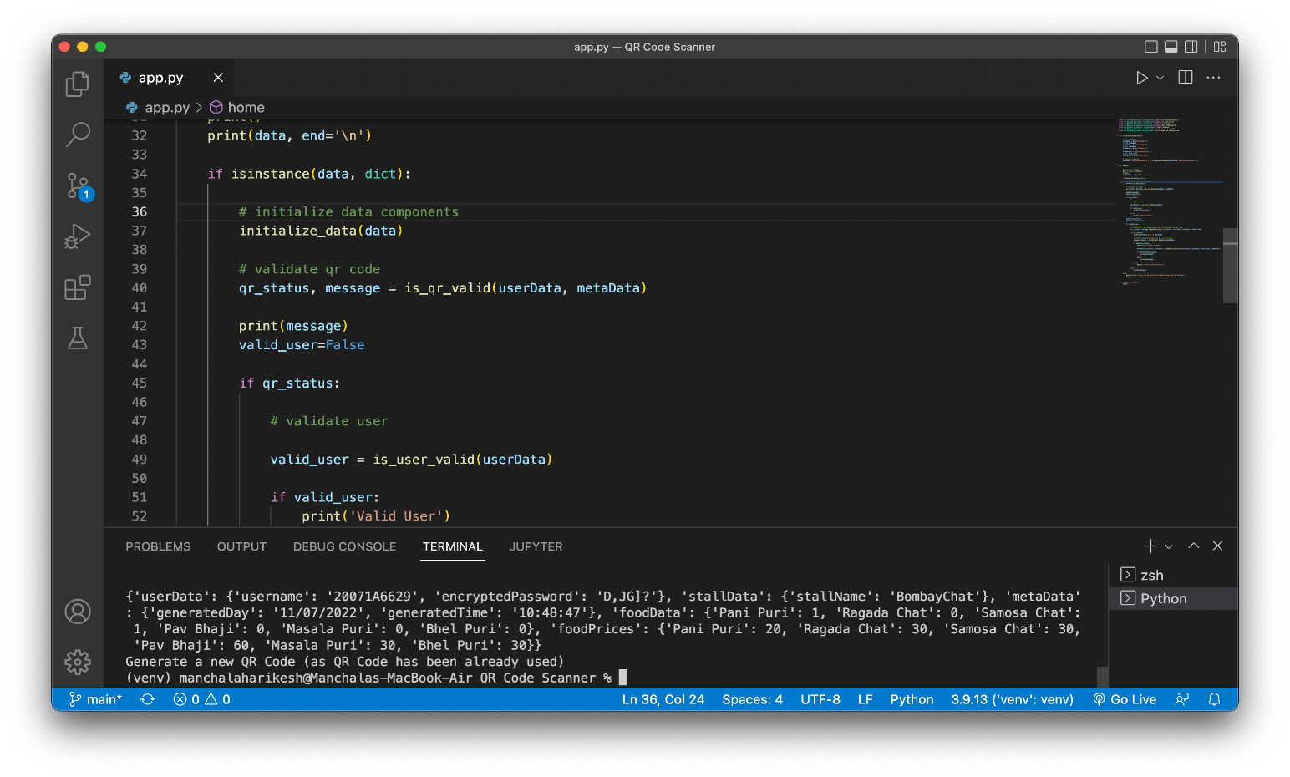

## Fig-5.9 Scanning QR for second time

**Source Code (QR Generator):**

This is the source of the flask app that has been the backbone of the QR Generator. This component handles the responsibilities like:

1. Rendering web pages based on request URL.
2. Managing GET and POST requests from users.
3. Generating and rendering of QR Code onto the web.
4. Allow users to download QR image by sending the file.

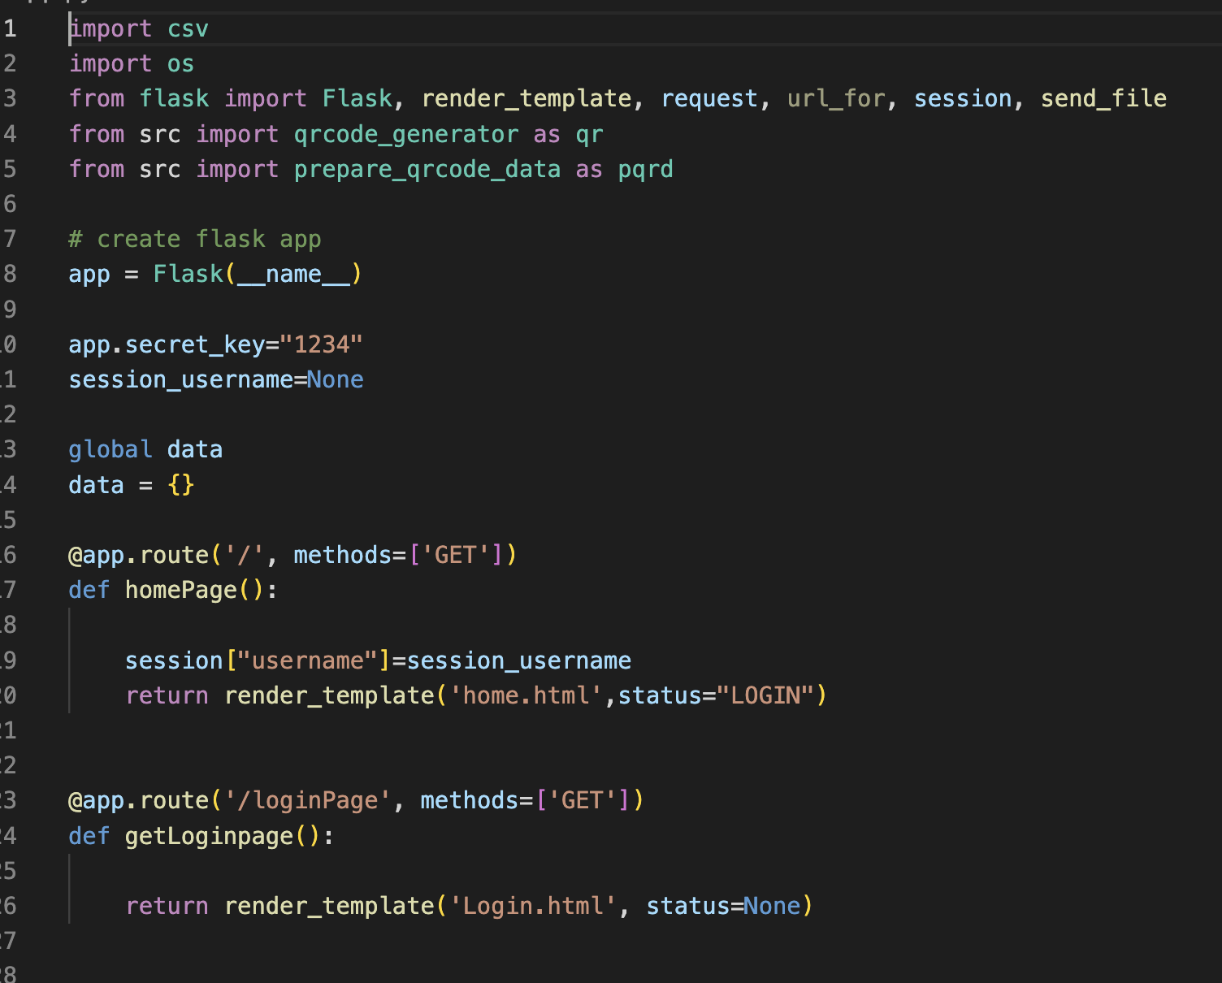

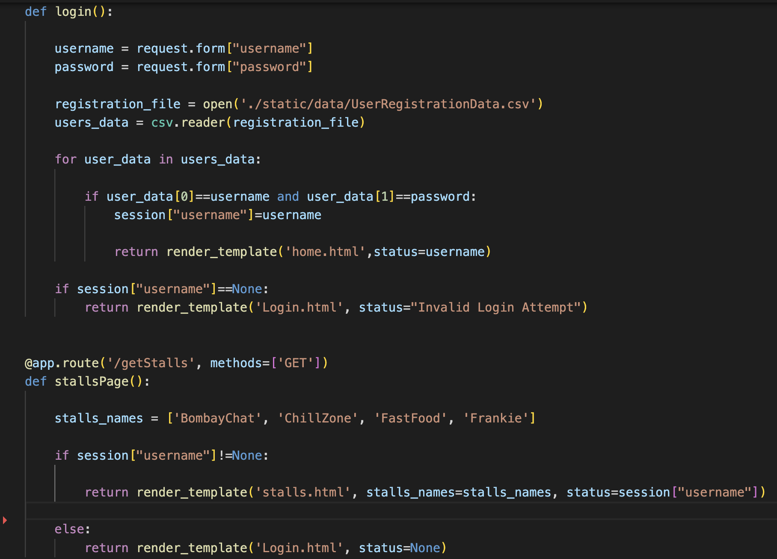

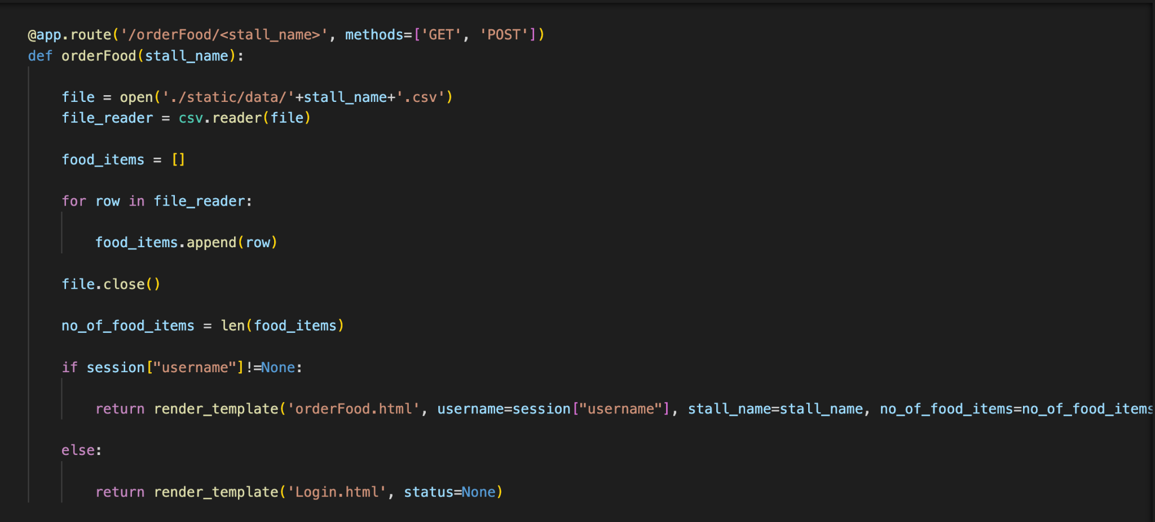

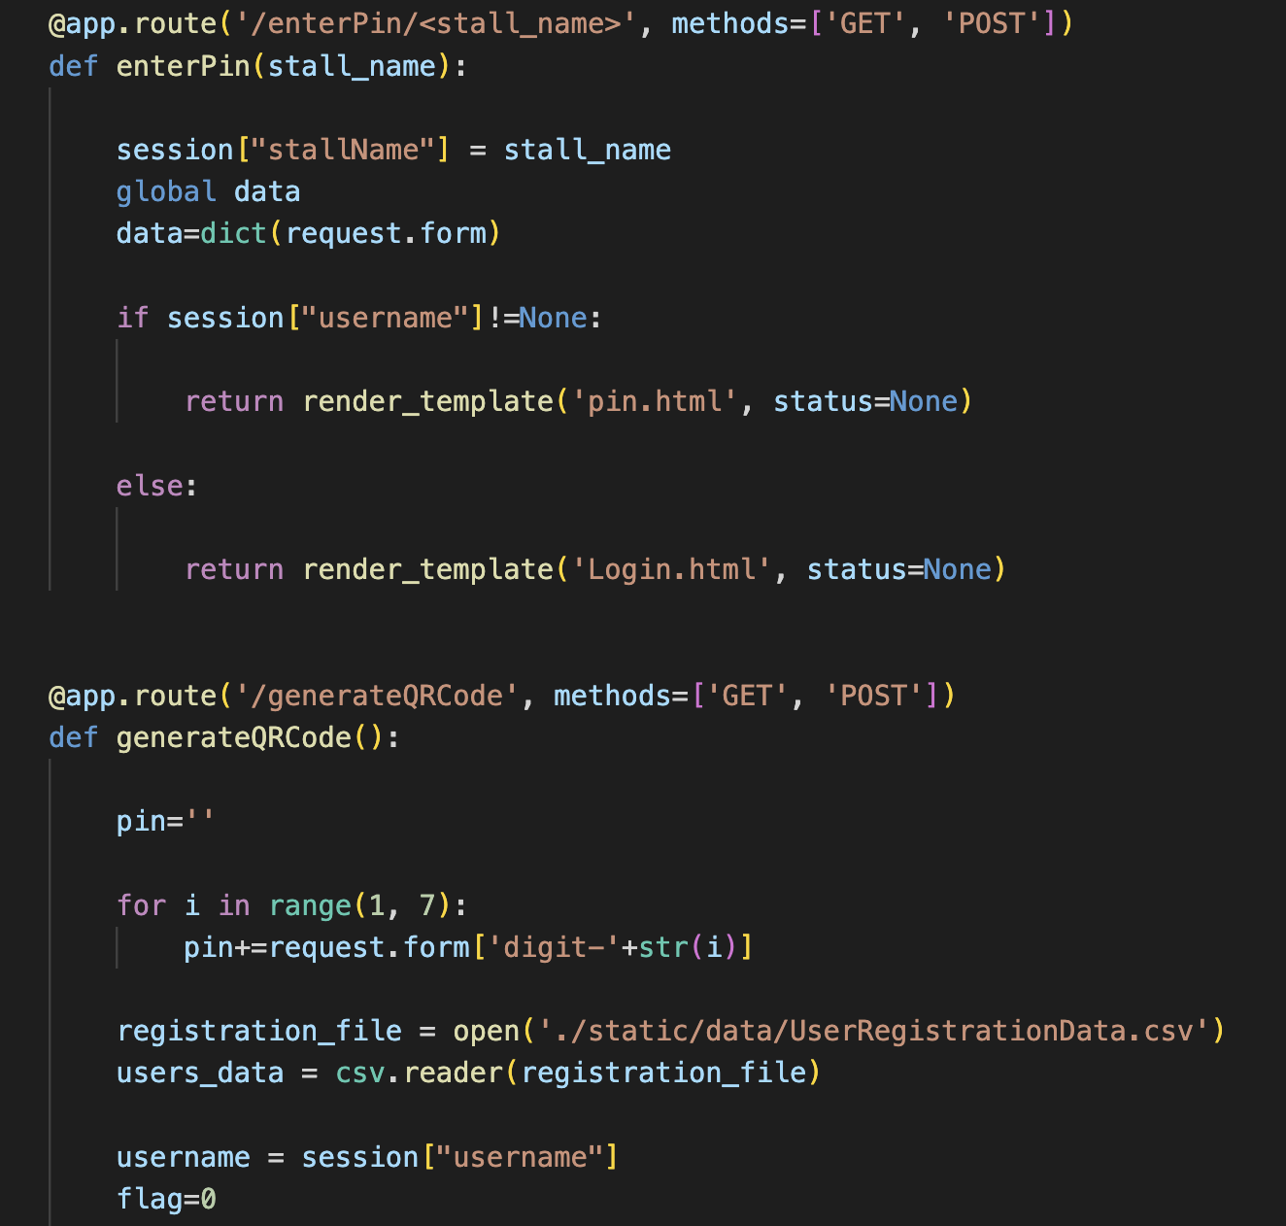

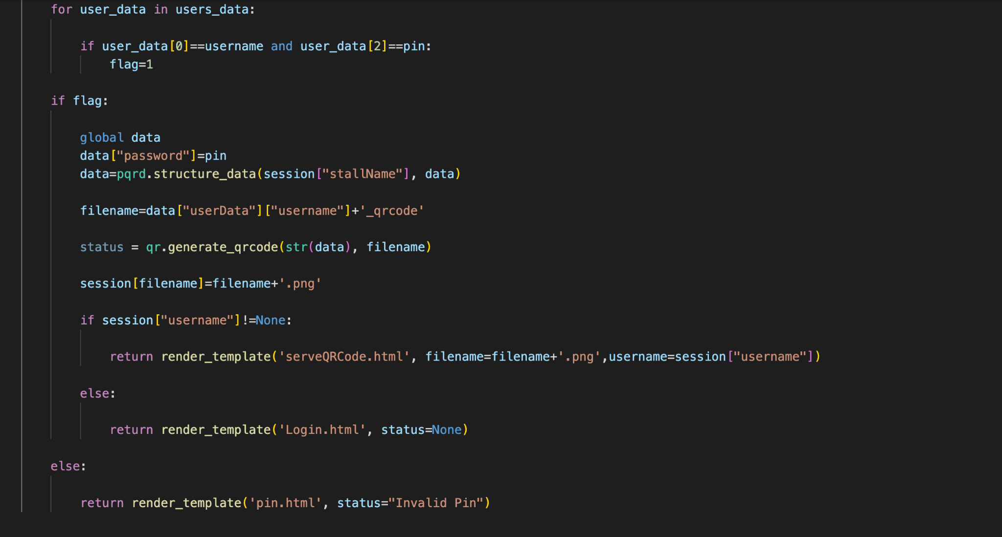

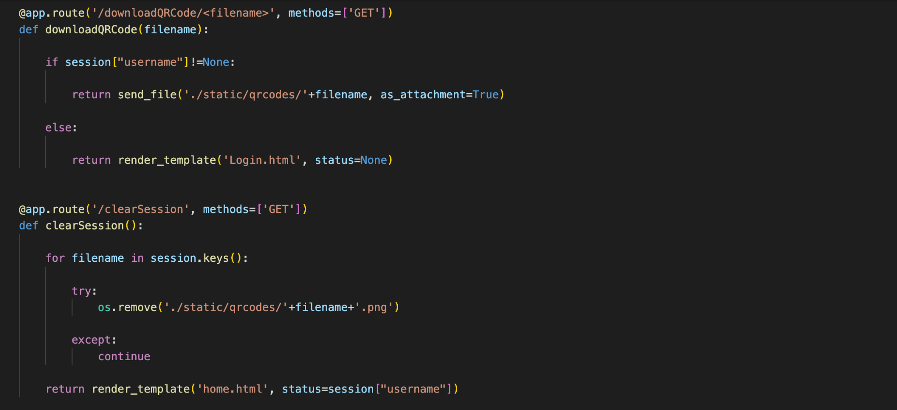

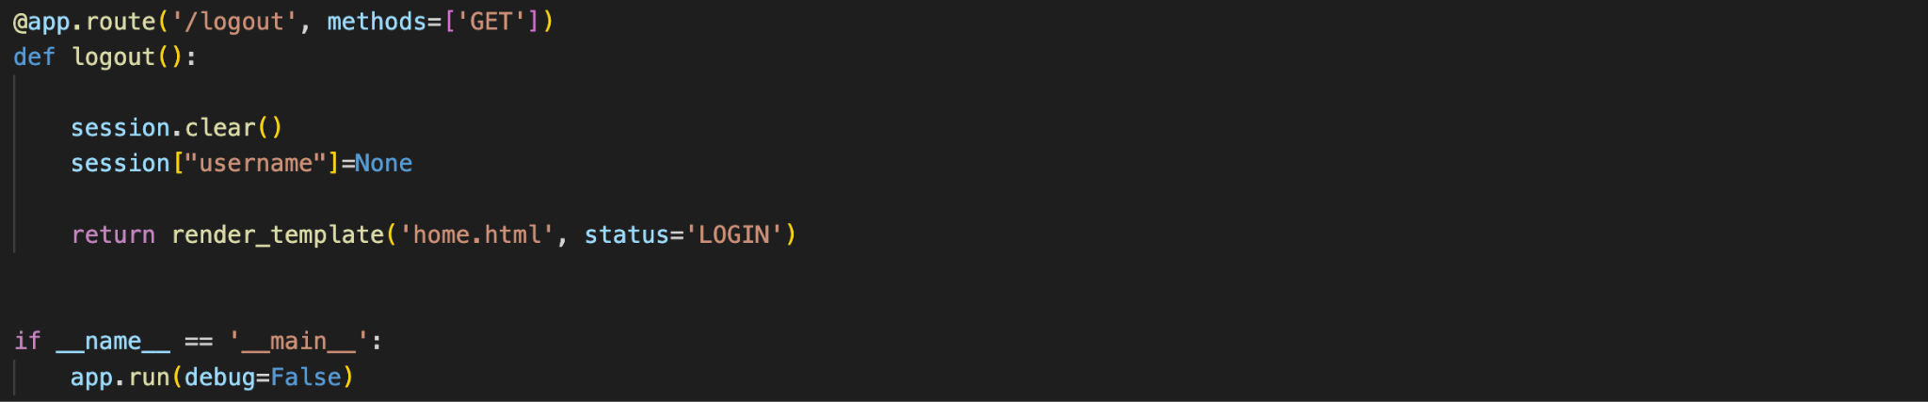

## Source Code (QR Scanner):

This module implements the core scanner functionality and it manages the control flow towards various other modules like:

1. Open and close the camera.
2. Extract Encoded data from QR Code.
3. Perform database operations to perform transactions based on extracted information.

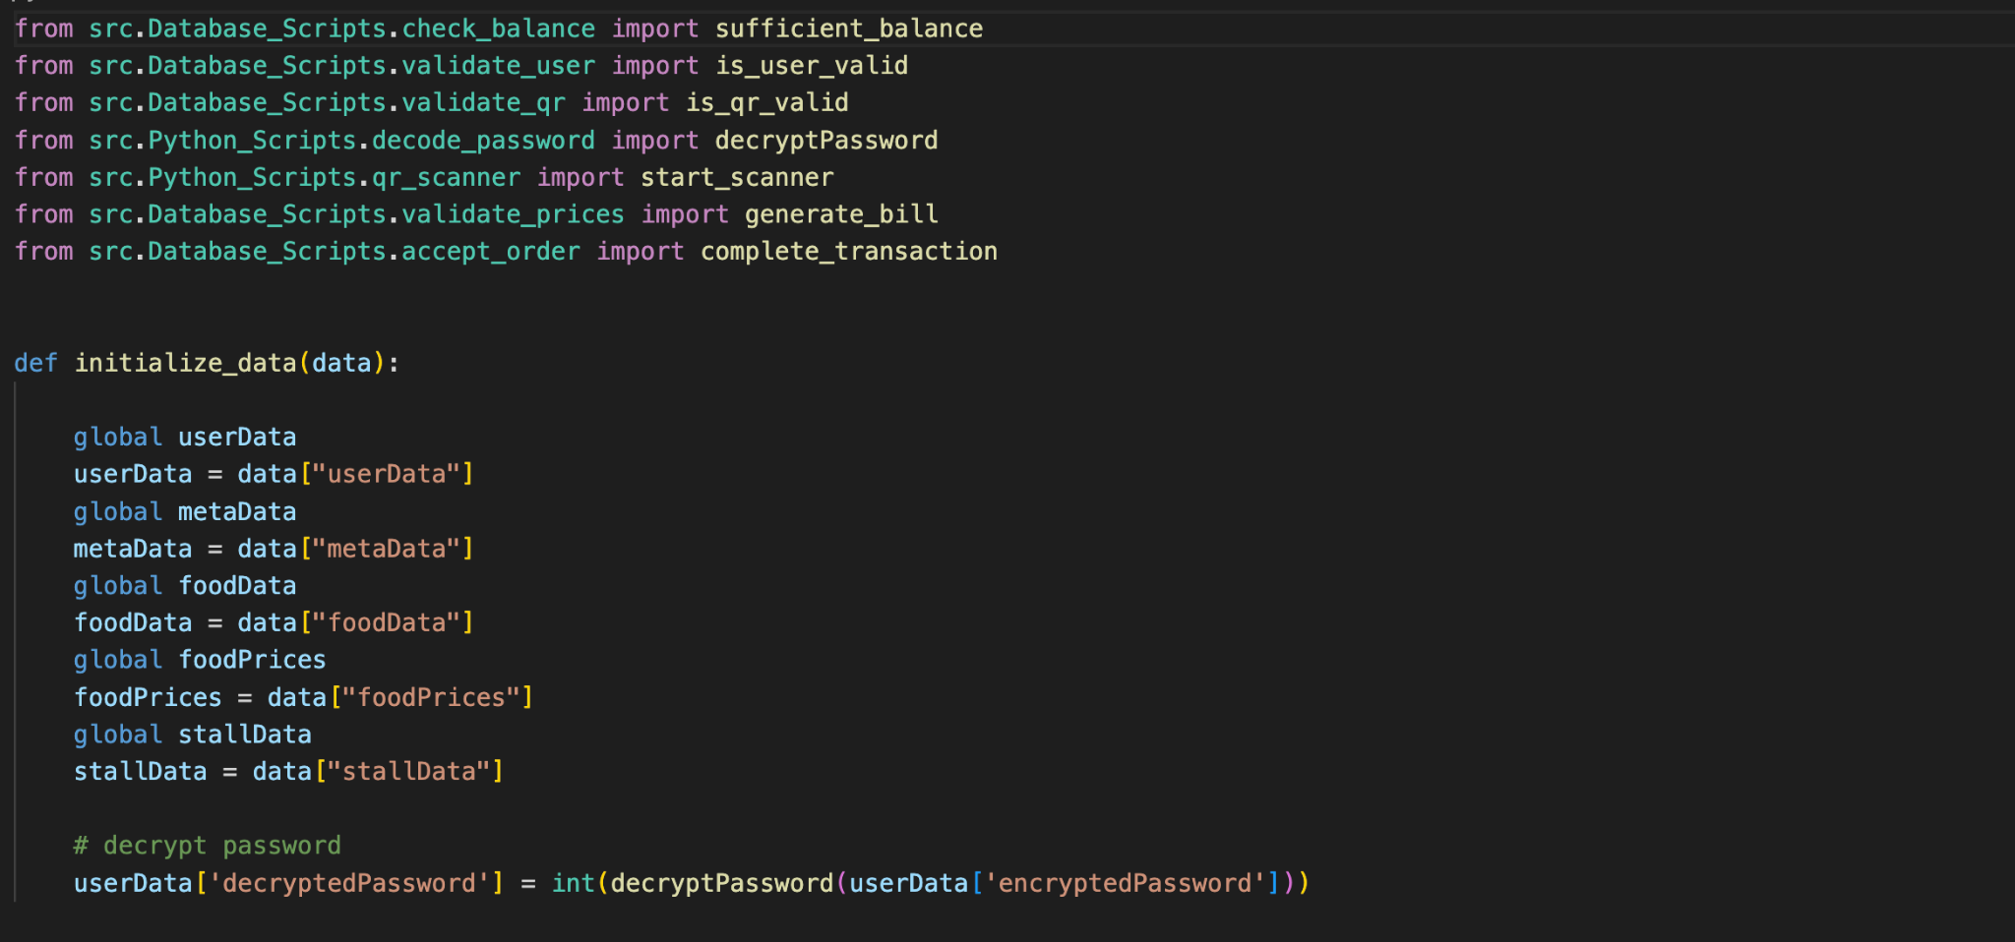

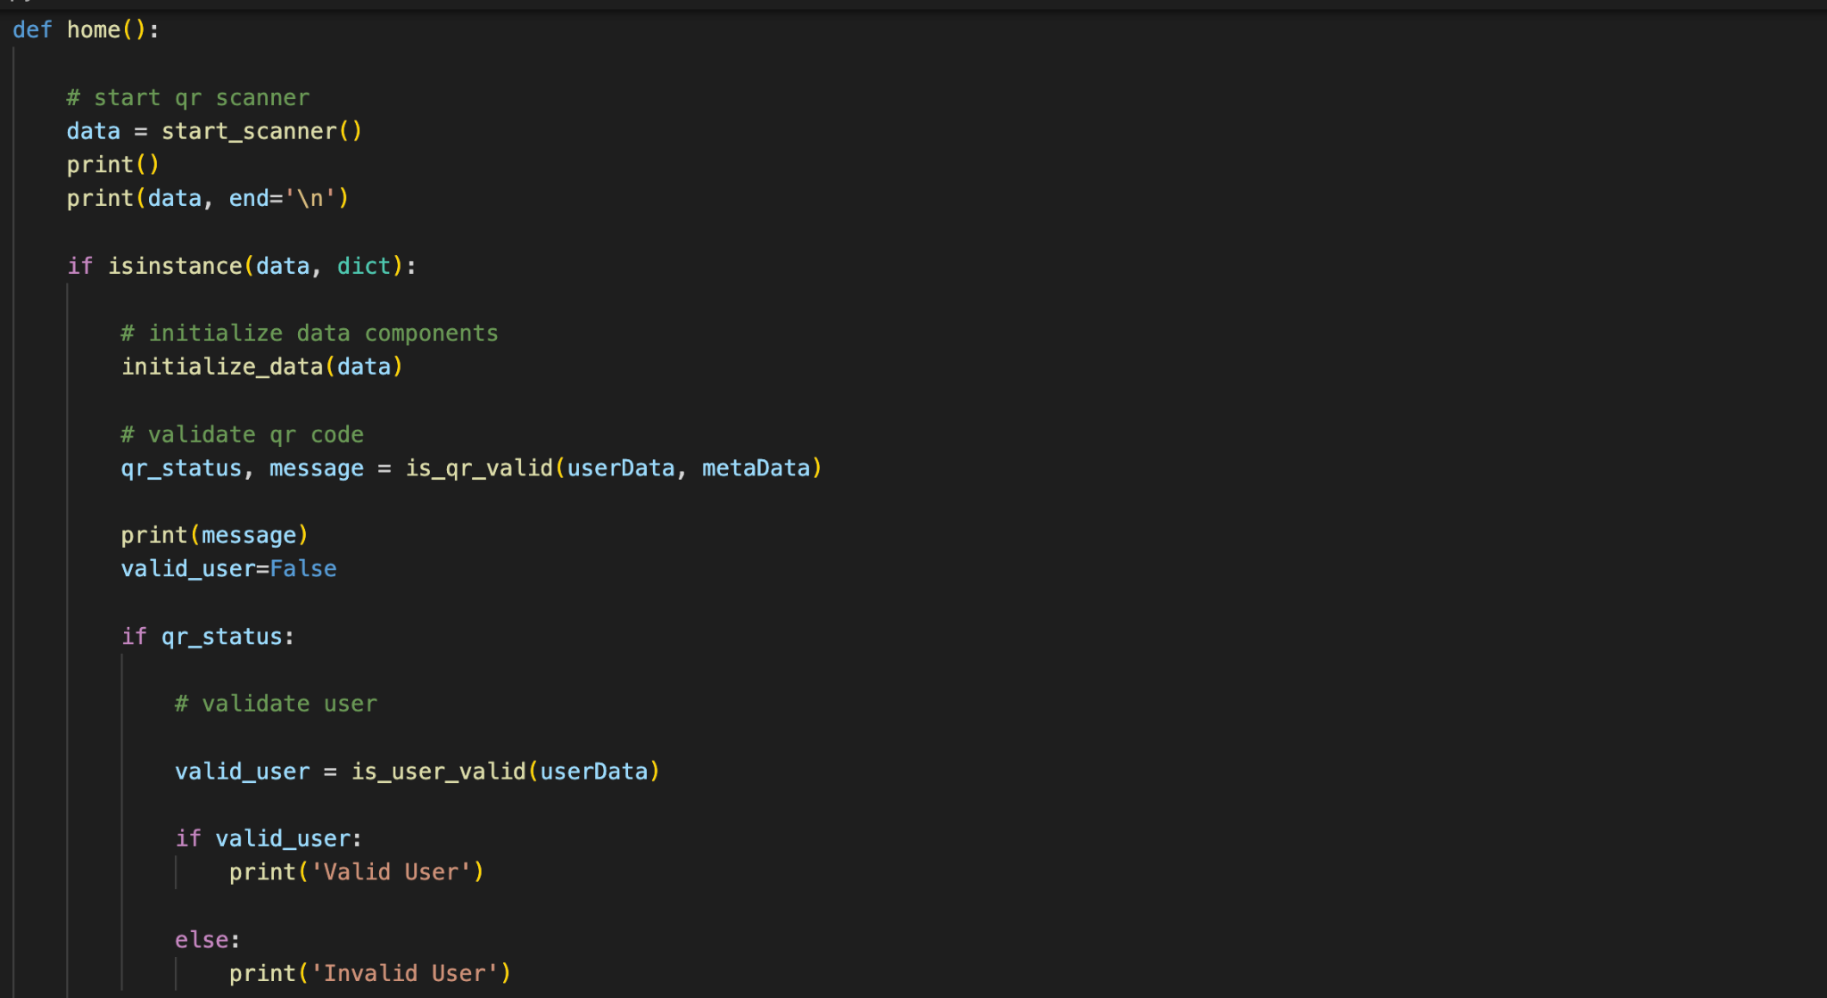

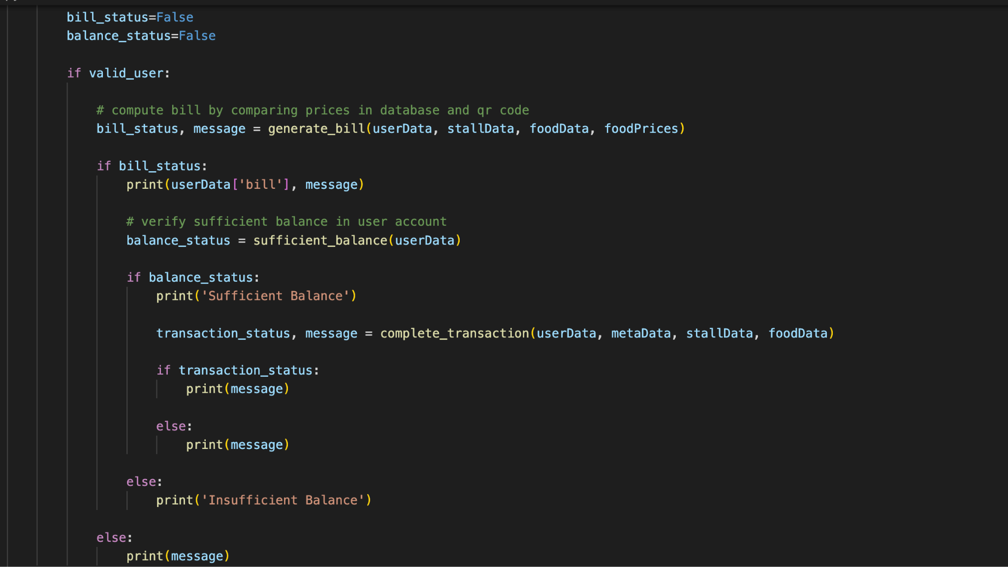

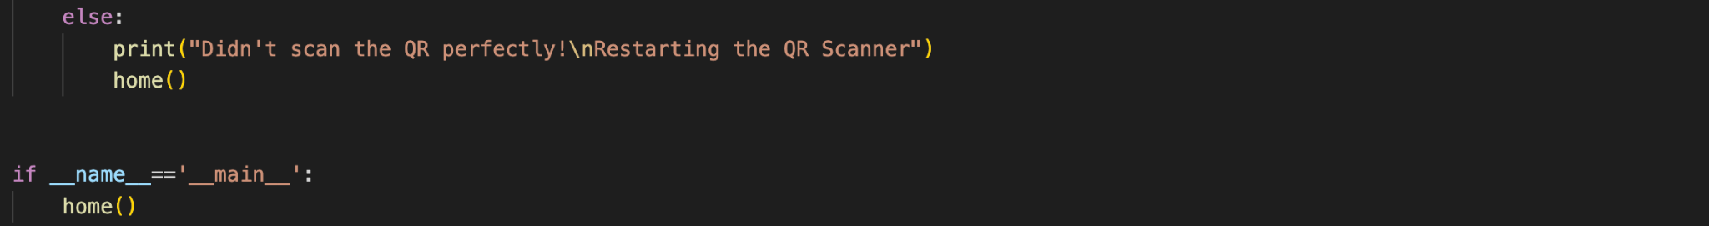

## 5.2 Evaluation of prototype Based on Desirability, Feasibility & Viability:

1. **Desirability:**
   1. The solution we offer is desirable because it solves the desired problem of making a payment when the user is offline.
   2. This solution is very desirable in the domain we restricted i.e., to our college canteen.
2. **Viability:**
   1. Our solution is viable because it overcomes most of the problems faced by the students.
   2. The application built is viable for the users to use as it is built using the latest available technologies.
3. **Feasibility:**
   1. We believe this solution is economically feasible.

**5.3 Design for Environment**

1. This solution is believed to be very sustainable.
2. This solution doesn’t harm the environment in any means of its usage.
3. The application infrastructure can be reused by making necessary programmatic changes.
4. In the aspect of hardware equipment, it won’t get worn out easily.
5. Changes can be made easily that increases reusability.

|  |
| --- |
| CHAPTER 6CONCLUSION AND FUTURE SCOPE6.1 Conclusion Students can make offline digital payments easily. Environment friendly as paper is not getting wasted to generate bills. Vendors will be benefited by fast and easy transactions. This helps in easy analysis of their order history and transactions. Vendors can’t have the list of the items ordered by students for an amount they received through UPI. This application can be an answer to these problems as we have the order history for each transaction. All those students who ever faced any trouble in making a payment may find this solution helpful. Students who faced an awkward situation of ordering food and unable to pay through UPI can relate themselves to this problem. It becomes easy for the vendors to handle transactions and keep note of the order history. This platform helps in fast completion of the transactions. Here by their internet is not needed for hunger instances and even slow internet leads to the processing of the payments in the transaction (UPI). 6.2 Future scope The crucial part or an interesting part of this project is “NO INTERNET REQUIRED”. We observe that many engineering colleges, construction sites, and intermediate colleges are located on the outskirts where they may not have proper internet connectivity of any service provider. These vendors may face the problem of cross-checking the payment status and the payee has to have the transaction without failure or processing. Sometimes it may take 2-3 days, then the vendor who might be stationary or mobilized faces problems. This project will add solutions to all the problems they face, hence this project has a great scope in the payments field. The interactive User Interface of this application adds scope to the project and helps us in getting rid of the competition because these days it's also a crucial part of scoping the project.  **CHAPTER-7**  **REFERENCES**  1.<https://flask.palletsprojects.com/en/2.1.x/quickstart/>  2. <https://www.w3schools.com/python/python_mysql_getstarted.asp>  3. <https://www.geeksforgeeks.org/python-generate-qr-code-using-pyqrcode-module/>  4. <https://learnopencv.com/barcode-and-qr-code-scanner-using-zbar-and-opencv/>  **Appendix A: User Surveys** |
| **A.1 Questionnaire for Users**   1. Have you ever faced difficulty in internet connectivity at college canteen? 2. Have you ever been in a situation where you have ordered your food and are unable to make a UPI payment due to lack of internet access? 3. If we provide you a service that enables you to make digital payments when you are offline. Do you think it's useful? (Services are restricted to college) 4. It's good to carry money rather than having such a service. 5. Do you think this application can make your process of placing an order easy? 6. What features would you be expecting from this application? 7. User Persona (you can share any of your experience if you have ever came across a situation as described above) |
| **A.2 Text Transcripts of User Responses** |



**Fig-A.2.a Survey**

1. Out of the total students surveyed 93.5% of people faced difficulty with internet connectivity.



**Fig-A.2.b Survey**

1. Out of 146 students 84.8% were unable to make successful UPI payments due to lack of internet.
2. They faced an awkward situation of being unable to pay after ordering the food.



**Fig-A.2.c Survey**

1. Out of 146 students 82.6% felt that a platform for making offline digital payments would be helpful.
2. While 8.7% answered it as it depends on the service provided.



**Fig-A.2.d Survey**

1. Out of 146 responses 39.1% felt that it is good to have such a platform.
2. While 37% said it's good to carry money to avoid any such issues with food ordering.
3. 23.9% felt that it depends on the solution provided.



**Fig-A.2.e Survey**

1. 82.6% of people felt this sort of application will be helpful in making their process of ordering food easy.